20170730 SRICAM Video Camera 1080P SP019

SP012 and New SP019 Notes

SAME

* Videos can only be played on phone. Photos are viewable on windows (using sd card only)
* There is no way to copy data from the camera (you can print screen on android)
* Effectively you are getting a larger view of the viewing area. (e.g. Currently I use 2 cameras to cover the front yard/driway. This camera covers the entire area with a similar resolution)
* The sensitivity of the alarm appears to be reduced. I would guess the sensitivity was kept the same for a larger area. (after toggling off and on this was better)
* The audio speaker output at the camera appears to be reduced. (will confirm)’
* This unit is mostly stable but sometimes pauses when viewing or playing back videos.
* Control on sensitivity is hit or miss. May not alarm when it should (cycle alarm status and it is ok?)

SP019 ONLY

* Occasionally drops the bottom half of the picture.

Common Issues:

Motion Detector Does not Trigger (Check by camera motion).

* Turn alarm off then back on and check with camera motion

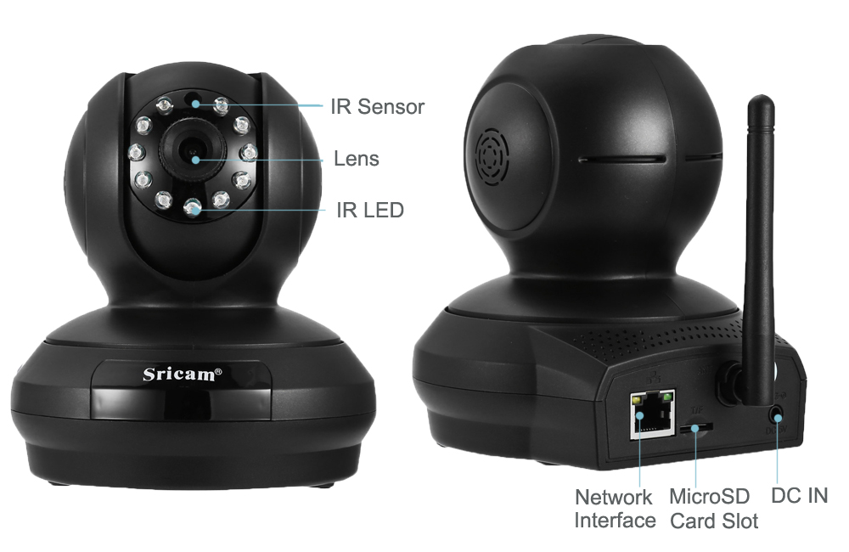

| **Main Features:**  1080P 2.0MP high-resolution image display  Two-way audio, easy communication  Support P2P, PNP: plug and play, no need DDNS and Port Forwarding setup  Onvif protocol: support NVR real-time monitoring, recording, and playback  Support up to 128GB micro SD card for recording and playback  Alarm: motion detection alarm, you can get alarm message by mobile phone, email or whistle sound  Built-in IR-cut, 11pcs IR illumination LEDs, night vision up to 10 meters  Input 100 - 240V, output 5V / 2A  Sricam App supports 4 x digital zoom  Technical feature: Pan / Tilt / digital zoom / infrared    **Brand:** Sricam  **Model:** SP019  **Shape:** Spherical Camera  **Color:** White  **Technical Feature:** Infrared,Other  **IP camera performance:** Motion Detection,Night Vision,Real-time video capture and recording,Support video control  **Motion Detection Distance:** About 15M  **Compatible Operating Systems:** Android,IOS  **Working Voltage:** DC 5V  **Protocol:** P2P  **Wireless:** IEEE 802.11 b/g/n  **WiFi Distance :** 15M  **Safety:** WEP, WPA, WPA2 encryption  **Mobile Access:** Android,IOS,Windows Mobile  **Alarm Notice:** Email Photo,FTP Photo  **Pan/Tilt-Horizontal Angle (degree) :** 355 degree  **Pan/Tilt-Vertical Angle (degree) :** 90 degree  **Local-storage:** TF / Micro SD card up to 128GB  **Language:** English  **Maximum Monitoring Range:** 20M  **FOV:** 80 degree  **Video Compression Format:** H.264  **Sensor:** CMOS  **Pixels:** 2MP  **Resolution:** 1920 × 1080,320 x 180,640 x 360  **Audio Input:** Built-in mic.  **Audio Output:** External speaker  **Infrared LED:** 11pcs  **Infrared Distance:** 10 meters  **Exterior Material:** Plastic  **Environment:** Indoor  **Waterproof:** No  **Operate Temperature (℃):** -10 - 50 Deg.C  **Package weight:** 0.591 kg  **Product size (L x W x H):** 13.50 x 10.50 x 10.30 cm / 5.31 x 4.13 x 4.06 inches  **Package size (L x W x H):** 18.50 x 15.00 x 11.00 cm / 7.28 x 5.91 x 4.33 inches  **Package Contents:** 1 x Sricam SP019 Indoor IP Security Camera, 1 x Power Adapter, 1 x Bracket, 1 x Net Cable, 2 x Screw, 2 x Expansion Bolt, 1 x Support Needle, 1 x English User Manual |
| --- |

